Source https://www.getyourguide.com/barcelona-l45/barcelona-catalan-paella-cooking-class-t442495/?ranking_uuid=4a1f21bb-bb30-4358-aa19-af23d2e96bc5
__________________________________________________________

Casablanca Valley Wine Discovery: 3–4 Wineries & Gourmet Lunch Experience
__________________________________________________________
★★★★★ 4.5/5 20 reviews

Add to wishlist ♡

__________________________________________________________

10 Hours | €15 per person

🏕  Image | 🏕  Image | 🏕  Image | 🏕  Image | 🏕  Image | 🏕  Image

__________________________________________________________
Experience Overview
Spend a full day immersed in Chile’s celebrated wine country on this small-group excursion through the scenic Casablanca Valley, a protected Denomination of Origin region famed for its premium whites and elegant Pinot Noir. Visit multiple boutique wineries, sample exceptional vintages, and learn about local terroir from expert hosts. With vineyard landscapes, cellar tours, and optional gourmet dining, this experience blends culture, gastronomy, and relaxation into one refined outing from Santiago.
__________________________________________________________
Tour Snapshot
- Duration: Approx. 10 hours
- Meeting Point: Hotel or accommodation pickup in central Santiago districts (Providencia, Las Condes, Vitacura, Downtown). If outside central areas, a meeting point will be assigned the evening before.
- Group Size: Small group (max approx. 13–15 travelers)
- Accommodation: Not included (day tour experience)
- Languages Available: English, Spanish
- Private Guide: Not included (shared guided tour)
- Transportation: Included (air-conditioned vehicle)
- Season: Available year-round
__________________________________________________________

Check Dates & Availability

Select participants: (Age 99 and younger) - 1 +

Choose date:
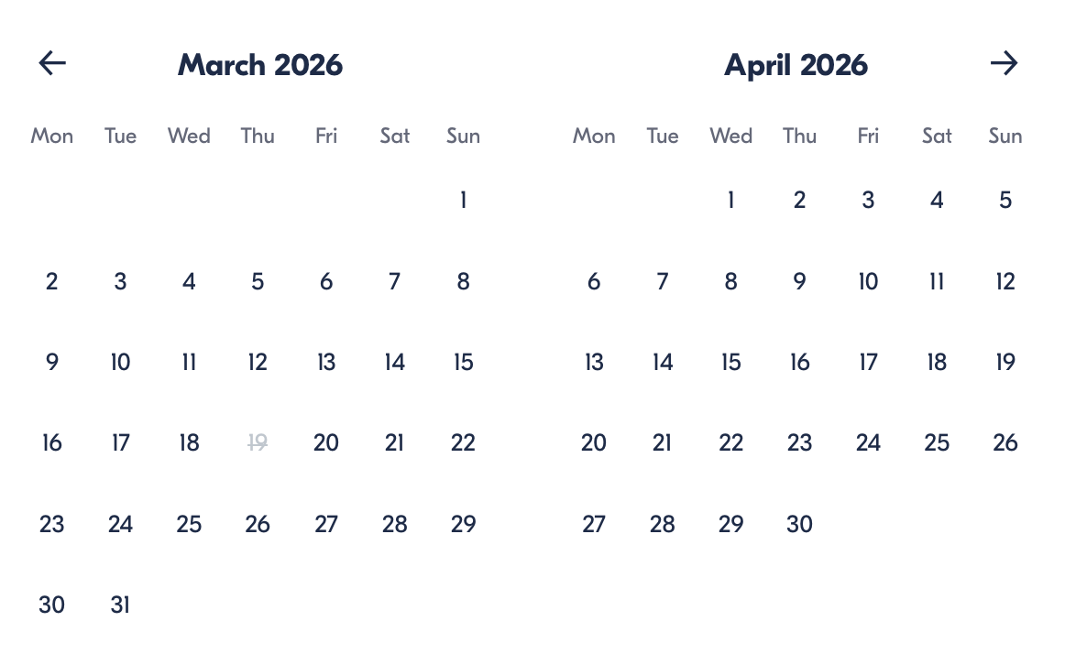

Check Availability

opens:

Participants: 1 March 16, 2026

Casablanca Valley Wine Discovery: 3–4 Wineries & Gourmet Lunch Experience

- Duration: 10 hours
- Offered in: English / Spanish
- Starts at: 8:00 AM

Cancellation:

- More than 24 hours before start: Full refund
- Less than 24 hours before start: No refund

Price breakdown: 1 Participant x €15

Total: €15

The total price includes all taxes and fees.

Add to cart Book now

__________________________________________________________
Tour Highlights
- Casablanca Valley Landscapes: Travel through vine-covered hills and river valleys en route to Chile’s premier wine region.
- Multiple Winery Visits: Explore 3–4 estates showcasing different styles, methods, and wine traditions.
- Guided Tastings: Sample carefully selected wines with explanations of production and regional characteristics.
- Organic Vineyard Stop: Meet alpacas and taste varietals such as Chardonnay, Carmenere, and blends at Emiliana Organic Vineyards.
- Sparkling Wine Experience: Enjoy sparkling tastings at Casa Valle Vinamar.
- Cellar Exploration: Visit underground barrel rooms and clay-jar storage at Bodegas RE.
- Optional Gourmet Finale: Finish at Viña Casas del Bosque’s Tanino Restaurant, known for refined cuisine and vineyard views.
__________________________________________________________
Detailed Itinerary

Day 1 – Casablanca Valley Wine Route
Your day begins with morning pickup from your Santiago accommodation before a comfortable 1.5-hour drive through Chile’s picturesque countryside toward the Casablanca Valley.
Your first stop is Emiliana Organic Vineyards, where you can stroll among vineyards, meet resident alpacas, and sample a selection of wines including Chardonnay, Carmenere, and premium blends. Next, visit Casa Valle Vinamar, where sparkling wines such as Brut, Rosé, and Extra Brut are introduced during a guided tasting.
Continue to Bodegas RE, a distinctive winery featuring underground cellars lined with oak barrels and clay vessels. Here you’ll taste unique blends such as Chardonnoir and Cabergnan alongside a table of bread, olive oil, balsamic vinegar, and olives.
The final stop is Viña Casas del Bosque, home to the renowned Tanino Restaurant, where guests can enjoy an optional gourmet lunch crafted by the culinary team and chief winemaker Alberto Guolo while overlooking vineyard gardens.
After a relaxing afternoon in wine country, return comfortably to Santiago.
Accommodation:
Not included (day experience only)
__________________________________________________________
Included in Price
- Transport in an air-conditioned vehicle
- Wine tasting at one participating winery (depending on option selected)
- Hotel pickup and drop-off in central Santiago areas
__________________________________________________________
Not Included
- Lunch (available to purchase onsite)
- Additional wine tastings (if not included in selected option)
- Gratuities
__________________________________________________________
Who Should Avoid This Tour
- Travelers Under 18: Wine tastings are part of the experience, and participants must meet the legal drinking age.
- Guests With Limited Mobility: Although transportation is accessible, vineyard terrain may include gravel paths, slopes, or uneven surfaces that can be challenging for some visitors.
- Individuals Sensitive to Alcohol: Since multiple tastings are offered throughout the day, this experience may not be suitable for those who prefer to avoid alcohol-related activities.
- Travelers Seeking a Fast-Paced Tour: This is a relaxed, wine-focused excursion designed for enjoyment rather than sightseeing intensity, so it may not suit those looking for a highly active itinerary.
__________________________________________________________
Important Trip Info
- Pickup zones: Complimentary pickup is offered in central districts, including Providencia, Downtown Santiago, Las Condes, and Vitacura.
- Outside city stays: Guests outside central zones may either pay extra for pickup or meet the group at a designated downtown hotel.
- Pickup confirmation: Exact pickup time is sent the evening before, usually around 9 PM.
- Age requirement: Minimum drinking age is 18.
- Accessibility: Transportation and surfaces are wheelchair accessible; strollers permitted.
- Footwear: Comfortable shoes recommended.
- Weather prep: Bring sunscreen and a light jacket.
- Group size: Maximum approx. 15 travelers.
- Itinerary note: Winery order may vary depending on availability.
__________________________________________________________

Cancellation Policy
Cancel at least 24 hours before the start time for a full refund.
- Cancellations within 24 hours are non-refundable.
- Changes within 24 hours are not accepted.
If the tour is canceled due to weather or insufficient participants, you will be offered a new date or full refund.
__________________________________________________________
What Our Clients Are Saying

Overall rating  4.5/5  ★★★★★  Based on 20 reviews | Review summary  Guide 4.5/5  Transportation 4.6/5  Service 4.7/5  Organisation 4.5/5

Filter  - All traveller types  - Couples  - Group of friends  - Families  By star rating  - All star ratings  - 5 stars  - 4 stars  - 3 stars  - 2 stars  - 1 star | Search reviews (e.g., guide)  Sort by:  - Top picks  - Latest reviews  - Best ratings  - Lowest ratings
__________________________________________________________
★★★★★
Elena M. — Italy
A wonderful day tasting wines and exploring beautiful vineyards. Each winery had its own style, and the lunch option was fantastic.
★★★★☆
Carlos R. — Spain
Very enjoyable experience with excellent wines and knowledgeable hosts. I only wish we had a bit more time at each stop.
★★★★★
Luciana P. — Brazil
Absolutely loved it. The scenery, the tastings, and the relaxed pace made this one of the highlights of my trip.
See more reviews
__________________________________________________________

Meta tags

Page - Casablanca Valley Wine Discovery: 3–4 Wineries & Gourmet Lunch Experience

Title: Casablanca Valley Wine Discovery: 3–4 Wineries & Gourmet Lunch Experience | Travellio Global

Description: Explore Chile’s premier wine region on a full-day Casablanca Valley tour with vineyard visits, tastings, and optional gourmet dining. Includes Santiago pickup and expert guidance.

H1 - Casablanca Valley Wine Discovery: 3–4 Wineries & Gourmet Lunch Experience
__________________________________________________________

